

**Semester Project**

**Report**

|  |  |
| --- | --- |
| Shawaiz Sher | 01-131232-082 |
| Abdul Moiez | 01-131232-002 |
| Rao Ahsan | 01-131232-076 |

**Storyline**:

In the mystical realm of Teraxia, a land steeped in magic and mystery, players embark on an epic journey as daring adventurers seeking to etch their names into the annals of legendary heroes. The air is filled with enchantment, and the sprawling landscapes are adorned with ancient ruins, dense forests, and towering mountains, each harboring secrets waiting to be uncovered. As you delve into this text-based RPG, you find yourself at the crossroads of fate, crafting a unique character that will become the linchpin in the unfolding tale. Your choices shape not only the destiny of your hero but the fate of Teraxia itself. Traverse the expansive world of Teraxia, a place brimming with diverse cultures, mythical creatures, and treacherous terrains. Engage in intricate quests that weave together a rich tapestry of dynamic storytelling, drawing you deeper into the lore of the land. Encounter intriguing characters, from wise sages to cunning rogues, each with their own motives and backstories. The heart of the game lies in the pulse-pounding battles that await you. Equip your hero with powerful weapons, mystical artifacts, and armor forged from the rarest materials. Face off against formidable monsters, each with unique challenges. Your strategic choices in battle will determine whether you emerge victorious or succumb to the perils of Teraxia. Character development is key to your success. Gain experience points through your adventures and battles, ascending through levels that unlock new skills and abilities. Choose your path wisely, for the decisions you make impact not only your hero's growth but the unfolding narrative of Teraxia itself. Immerse yourself in the fantastical landscape of Teraxia, where every quest is a chance to uncover hidden truths, and every encounter shapes the destiny of this magical realm. The game promises an immersive experience, blending captivating storytelling, strategic gameplay, and the thrill of exploration in a world waiting to be discovered.

**Features**:

1. **Hero**

* user_name: stores the username entered by the user.
* class_type: stores the class type chosen by the user.
* health_points: stores the health points of the user. Health points will be modified during battles.
* exp_points: stores the experience points of the user. User will level up when the user accumulates a certain amount of experience points.
* level: stores level of player. Increments after experience points earned.
* inventory: stores inventory items collected during the quests. Can be shown in inventory menu

1. **Monster**

* monsterHealth: stores monster health. Monsters are given different health in different quests.
* monsterDamage: used for generating random monster attacks. Set according to difficulty levels.

1. **Quest**

* Player: the structure of hero in the quest
* Monster: the structure of monster in the quest
* exitQuest: used to store Boolean incase the player wants to exit the quest amid battle
* lostBattle: used for quest2 and quest3, if the user loses a battle.

**Game Mechanics**:

* initializeCharacters: part of function where user decides their username, class using the Hero struct defined
* displayMenu: displays the main menu of the game. It is the first thing to output after the main game loop begins.
* displayHeroInformation: displays the values of members stored in Hero struct. Has return type void.
* displayInventory: displays the inventory of the character.
* setGameColor: sets the color of game using 5 different colors with the help of ANSI Color codes.
* displayQuestMenu: displays a menu with different quests options.
* gainExperience: gains experience after earning xp for progressing in story, solving riddles.
* levelUp: levels up after certain xp points are accumulated. Health points are increased by +50 for every level.
* Quest/battle functions: Quest functions made for each quest, with their sub-functions implemented for battling, puzzling etc.

**Main Flow**:

* **Character Selection:**

Player will choose username and a class type from different options.

* **Game Loop**

Main game loop starts after initializing the character.

* **Menu Options**

Players are presented with different menu options for engaging in quests, opening profile, choosing a color and viewing inventory.

* **Quests**

Player will engage in a quest, discover dynamic storyline, solve puzzles and fight different types of enemies. User can quit the quest during battling.

**Flowcharts**:

Main Loop

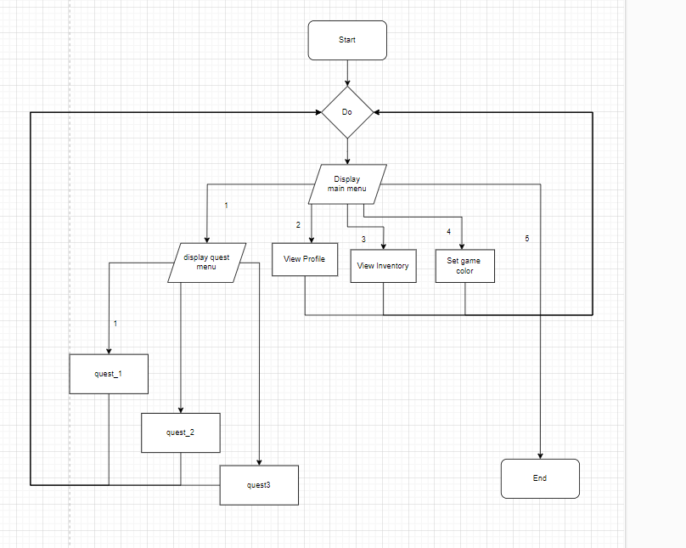

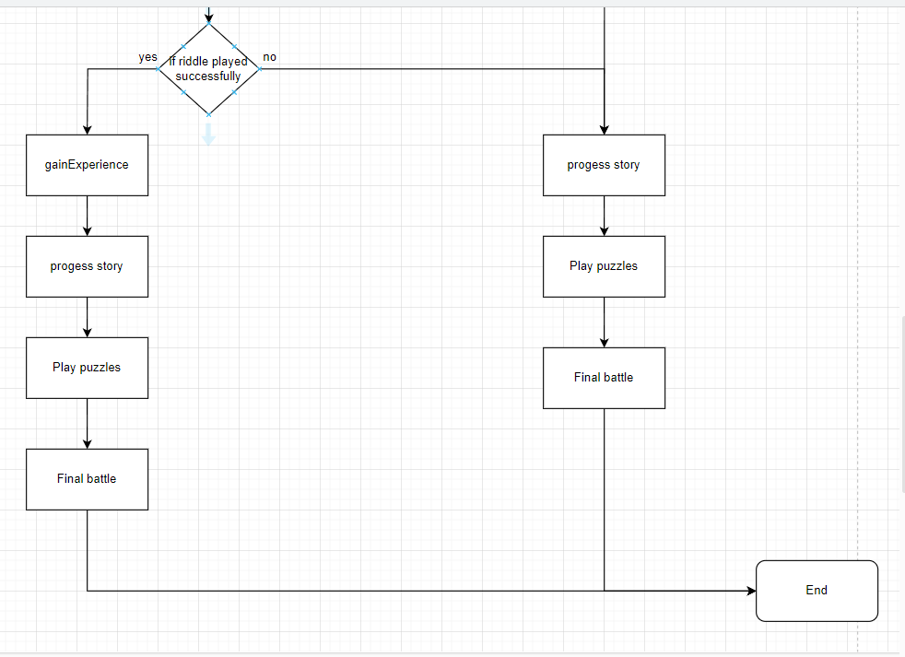

**Workload Distribution**:

* **Shawaiz Sher**

1. Development of game flowchart including main and Quest 1.
2. Basic structure of the code, including initialization of characters, looping of game, menus and Quest #3

* **Abdul Moiez**

1. Development of structures of monsters, Quest and battling system. Flowcharts of Quest 1 and other details.
2. Developing poster for the game

* **Rao Ahsan**

1. Development of Quest 2 and its corresponding flowcharts. Participated in code testing and debugging.

**Conclusion:**

* In conclusion, Teraxia offers a rich and unique gaming experience with a vast variety of features designed to captivate players in a fantastical realm. The game blends dynamic storytelling, character development, and strategic battles. Players embark on a heroic journey, selecting their character from unique classes, each with distinct abilities and traits. The quests, ranging from simple tasks to epic adventures, contribute to an overarching storyline, allowing players to explore the diverse landscapes and hidden realms of Teraxia

**Q: What parts were the hardest?**

**Ans:** Game loop and creating structures for different quests was the hardest part. Moreover other features like battling and diverse branches also posed a challenge but was sorted out eventually.

______________________________________________________________________________